 **Net Promoter Score(NPS) Widget Builder**

**Report**

***Submitted by***

**Krishna Agrawal**

**January 2023**

**ACKNOWLEDGEMENT&ABSTRACT**

First and foremost, I would like to thank the Lord Almighty for His presence and immense blessings throughout the project work.

I wish to express my heartfelt gratitude to Priyanka Gathraj , Senior HR Manager

for Giving Me This Opportunity and Her valuable support and encouragement in carrying out this work.

Last, but not least, I am deeply indebted to my parents who have been the greatest support while I worked day and night on the project to make it a success

This report presents an,Net Promoter Score(NPS) Widget Builderin in which the user can Express Their Valuable Feedback . The objective of the Webapp is that measures customer experience and predicts business growth. This proven metric transformed the business world and now provides the core measurement for customer experience management programs the world round.

I divided the whole project into 2 parts. The first part was creating all the UIs that are required in the Website and the second part was connecting the UIs and integrating the Database with it.

**INDEX**

|  |  |  |
| --- | --- | --- |
| **CHAPTER NO.** | **TITLE** | **PAGE NO.** |
|  | ACKNOWLEDGEMENT&ABSTRACT | 2 |
| 1 | INTRODUCTION   1. What is Net promoter score 2. The NPS Calculation   2.1 A Core Metric for CEM | 4  5 |
| 2 | 1. Why is NPS important    1. How to calculate NPS    2. How to interpret Net Promoter Score    3. What is a good NPS score?    4. What is a bad NPS score?    5. How to run surveys and collect NPS feedback    6. How to read your NPS result | 6  7  8  9  10  11  13 |
| 3 | 1. Summary | 18 |
| 6 | 1. CONCLUSION | 19 |
| 7 | 1. SNAPSHOTS | 20 |

**INTRODUCTION**

* **Net promoter score is a widely used market research metric that is based on a single survey question asking respondents to rate the likelihood that they would recommend a company, product, or a service to a friend or colleague**

1. **What is Net promoter score**

Net Promoter Score or NPS measures customer experience and predicts business growth. This proven metric transformed the business world and now provides the core measurement for customer experience management programs the world round.

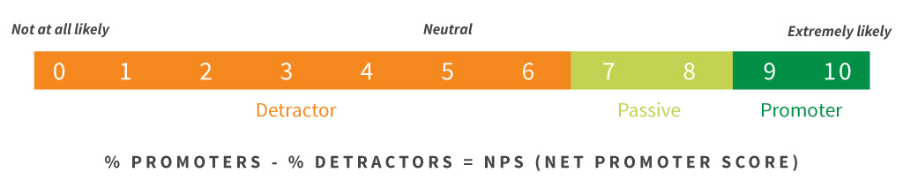

1. **The NPS Calculation**

Calculate your NPS using the answer to a key question, using a 0-10 scale: How likely is it that you would recommend [brand] to a friend or colleague?

Respondents are grouped as follows:

* **Promoters** (score 9-10) are loyal enthusiasts who will keep buying and refer others, fuelling growth.
* **Passives** (score 7-8) are satisfied but unenthusiastic customers who are vulnerable to competitive offerings.
* **Detractors** (score 0-6) are unhappy customers who can damage your brand and impede growth through negative word-of-mouth. Subtracting the percentage of Detractors from the percentage of Promoters yields the Net Promoter Score, which can range from a low of -100 (if every customer is a Detractor) to a high of 100 (if every customer is a Promoter).

### A Core Metric for CEM

* Use your NPS as the key measure of your customers’ overall perception of your brand. Because NPS is a leading indicator from growth, it provides the best anchor for your customer experience management (CEM) program. Complement NPS with other metrics and insights from various points along the customer journey, and you have a comprehensive, actionable view of your customer experience performance.

1. **Why is NPS important**

* NPS can be used as a predictor of business growth. When your company’s NPS is high (or, at least, higher than the industry average), you know that you have a healthy relationship with customers who are likely to act as evangelists for the brand, fuel word of mouth, and generate a positive growth cycle. NPS is a valuable metric on a strategic level, but by itself, the score is not enough to be useful or paint a complete picture. The overall NPS system is important because it allows businesses to: Ask follow-up questions as part of the standard NPS survey. By asking customers why they've given a specific score, organizations of any size can understand what they're doing well and where they could be improving Track and quantify a score over time, creating internal benchmarks Rally all employees around one mission-critical objective: earning more enthusiastic customer.
  1. **How to calculate NPS**
* Net Promoter Score scale: detractors, passives, promoters
* NPS is calculated by subtracting the percentage of customers who answer the NPS question with a 6 or lower (known as ‘detractors’) from the percentage of customers who answer with a 9 or 10 (known as ‘promoters’).

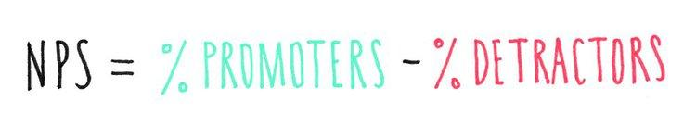

* In the Net Promoter system, customers are categorized into three groups—promoters, detractors, passives—depending on how they answer the standard “how likely are you to recommend us” question:

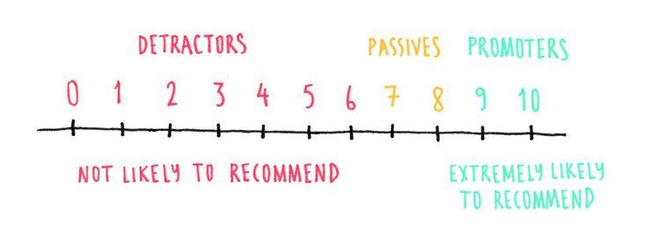

* Promoters (score of 9 and 10) represent a company’s most enthusiastic and loyal customers: these people are likely to act as brand ambassadors, enhance a brand’s reputation, and increase referral flows, helping fuel the company's growth.
* Detractors (score of 0 to 6, included) are unlikely to recommend a company or product to others, probably won’t stick around or repeat purchases, and—worse—could actively discourage potential customers away from a business.
* Passives (score of 7 or 8) are not actively recommending a brand, but are also unlikely to damage it with negative word of mouth. Although they are not included in the NPS calculation, passives are very close to being promoters (particularly when they give a score of 8), so it always makes strategic sense to spend time investigating what to do to win them over.
  1. **How to interpret Net Promoter Score**
* [Net Promoter Score](https://www.hotjar.com/website-feedback-tools/) is always expressed as a number from -100 to 100; the score is negative when a company has more detractors than promoters, and positive in the opposite situation.
* In the Net Promoter system, average scores vary greatly between industries:
* A [2018, US-based study by the Temkin group](https://temkingroup.com/product/net-promoter-score-benchmark-study-2018/) saw average NPS values ranging between 0 (internet and TV service providers) and 39 (auto dealers);
* Another [2018, US-based study by the Temkin group](https://temkingroup.com/product/net-promoter-score-benchmark-study-2018/) found NPS averages ranging between -1 (Internet service providers) and 65 (department/specialty stores).
* Knowing NPS averages by industry helps to understand how key competitors in a specific market are doing and gives extra context to what counts as a ‘good’ or ‘bad’ score.
  1. **What is a good NPS score?**
* Given the available -100 to +100 range, any score above 0 reads as ‘good’ because it indicates that a business has more promoters than detractors.
* Top-notch companies generally have an NPS of 70 and above, but if you’re thinking this is the domain of big, global companies only, think again: [in 2018](https://learn.foresee.com/foresee-digital-experience-index-q3-2018), Netflix had an NPS of 64, PayPal scored 63, Amazon 54, Google 53, and Apple 49.
* A perfect score of 100 indicates that every survey respondent would recommend a company to someone else—a score that nobody [has ever achieved](https://www.inc.com/dana-severson/whats-a-good-net-promoter-score-hint-its-not-what-you-might-expect.html).
  1. **What is a bad NPS score?**
* Any score below 0 indicates that a business has more detractors than promoters. Here’s where industry NPS benchmarks like the ones mentioned above are useful: while an NPS score of -3 may seem bad in isolation, it’s hard to interpret it without comparable scores from key industry players—if the industry average was -10, suddenly the score would not look as bad.
* This said, even if the bar is set low, a negative NPS is a sign that a business has some serious work to do to improve the situation, reduce the number of unhappy customers, and generate more promoters.
  1. **How to run surveys and collect NPS feedback**
* If you are interested in calculating and tracking NPS for your business, the first step is to run an NPS survey to collect customer feedback. You can choose between two main ways of doing it, depending on whether you want to ask in-the-moment feedback or collect it sometime after a customer has had any experience with your company

**1. Website survey**

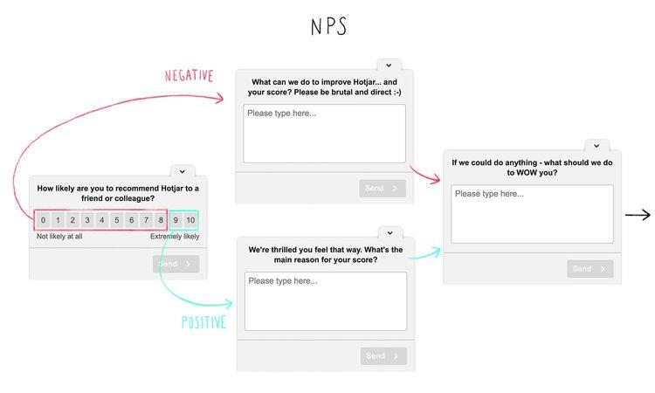

* On-page/website pop-up surveys let you capture your customers’ feedback while they are still on your website. You can set up the [NPS survey](https://www.hotjar.com/survey-templates/customer-satisfaction-nps/) so it appears on your main conversion pages (for example, the thank you page people see after completing a purchase), or trigger an exit survey right before people leave the website.
* To run this survey, you’d start by asking the standard NPS question: “On a scale of 0 to 10, how likely are you to recommend [company] to a friend/colleague?”. For maximum value, you should always follow it up with one or two additional questions:
* If the customer picks a number between 0 and 8 (detractors - passives), apologize for the negative experience and ask “What can we do to improve your score?
* If they pick a 9 or 10 (promoters), follow up with enthusiasm and investigate further by asking “What’s the main reason for your score?”
* You can even add a third optional question for people to share their ideas on what else you should be doing

**2. Email survey**

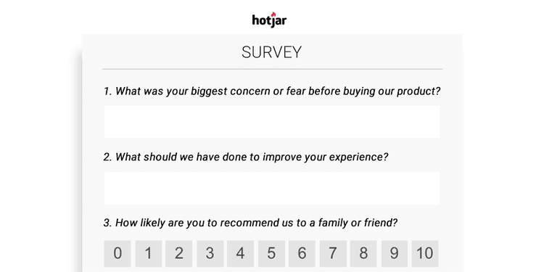

* Instead of presenting people with a website pop-up, you can collect NPS data by emailing customers and inviting them to fill in a survey after a purchase or key interaction with your business.
* Email surveys require a bit more work on the customers’ part (open the email → click on the survey → get taken to a separate page → fill it in and submit), and there is an obvious time delay between sending out the survey and getting results.
* On the plus side, giving your customers the time to experience the product/service they received from you (for example, 15 or 30 days) might help them develop an even clearer sense of whether or not they would recommend it.
  1. **How to read your NPS results**
* Although NPS measures the likelihood of an action based on experience, it has proven to be a reliable predictor of future business growth or decline. In other words, it helps you see trouble coming—just like sonar on a boat helps you spot icebergs in time to course-correct—both at the individual and macro customer level.
* The Temkin group study quoted earlier also found a high correlation between NPS and customer experience: on average, in the US “[customer experience leaders](https://temkingroup.com/product/net-promoter-score-benchmark-study-2018/) enjoy an NPS that is 21 points higher than the NPS of customer experience laggards.”
* Here’s how to read your NPS results after running the survey and collecting data:

**1. Look at data segments**

* Your company's Net Promoter scores may vary across different segments (e.g. age group, gender, long-term customers, higher-spending customers, etc.). When you’re just getting started with NPS you don’t need this level of depth: any information you collect at this point will help you start to paint a clear picture.
* Once you are a more advanced user, you can super-charge your NPS analysis by putting segmentation systems in place and identifying how to adapt your approach to different types of customers.

**2. Keep tracking performance over time**

* Because NPS is a real-time metric, you could look at it daily if you wanted—but its true power is revealed over time when you can see trends and fluctuations:

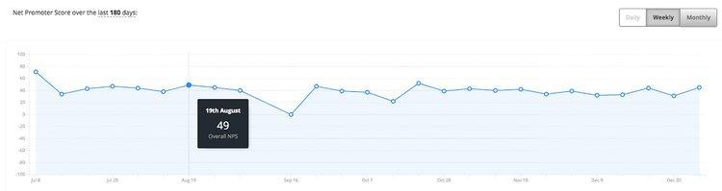

* It may be difficult to get high response rates for every NPS survey you send out. For the ones that do get a large number of respondents, keep those handy as benchmarks for what to improve upon when your next survey comes around. Once you have an understanding of how NPS changes over time, you can investigate what factors may have contributed to it—which is when the next point comes in handy.

**3. Close the loop**

* NPS is more than just a number: the real goldmine is the information you collect by asking follow-up questions as part of the survey (and even beyond that).
* It’s crucial that you have an underlying methodology for interpreting your NPS score and that you always close the loop with customers to understand the context and reasons behind their score. Using one-to-one interviews, follow-up sessions, etc., helps you zoom in on specific issues, understand what can and should be improved, and focus your efforts in a truly customer-centric direction.
* NPS case studies
* Knowing your NPS is a great starting point, but to truly improve it—and your likelihood of business growth—you need to deep-dive into why your customers scored you the way they did. Here are two examples and stories to get you inspired:
* Hotjar’s NPS case study



* Like a lot of our customers, [we use Hotjar to track NPS](https://www.hotjar.com/blog/1-year-into-nps/). We have been doing it for more than a year and learning as we go; in this article from 2018, we shared a few lessons about owning the metric, sending the NPS survey at the right time in the customer journey, segmenting the results, and closing the loop.
* Taylor and Hart's NPS case study



* Taylor and Hart is a London-based jeweler specializing in bespoke engagement rings. They have one of the highest NPS in the industry (80 and above), and this [NPS case study](https://www.hotjar.com/blog/nps-case-study/) covers how using [Net Promoter Score](https://www.hotjar.com/blog/customer-feedback-questions/) helped them secure repeat business, expand their product offerings, and grow at an impressive pace.
* NPS in a nutshell
* The Net Promoter Score (NPS) measures the loyalty of a company's customer base with a score from -100 to +100, which comes from customers answering the question "How likely are you to recommend this company to a friend or colleague?"
* To grow your business, you need satisfied customers or ‘promoters’ who talk about you enthusiastically and send referrals your way—and the way you measure your promoters is by checking how many people scored you 9 and 10 in an NPS survey.
* NPS is a useful number for evaluating and benchmarking your business, but its real value is in the answers to the follow-up questions you get to ask as part of the survey: "What’s the main reason for your score?", "What can we do to improve our business - and your score?", and"What can we do to WOW you?" Customer satisfaction is key to getting new customers and securing old ones.

1. **Summary**

* The Net Promoter Score is an index ranging from -100 to 100 that measures the willingness of customers to recommend a company's products or services to others. It is used as a proxy for gauging the customer's overall satisfaction with a company's product or service and the customer's loyalty to the brand.
* Customers are surveyed on one single question. They are asked to rate on an 11-point scale the likelihood of recommending the company or brand to a friend or colleague. “On a scale of 0 to 10, how likely are you to recommend this company’s product or service to a friend or a colleague?” Based on their rating, customers are then classified in 3 categories: detractors, passives and promoters.
* The Net Promoter Score (NPS) is determined by subtracting the percentage of customers who are detractors from the percentage who are promoters. What is generated is a score between -100 and 100 called the Net Promoter Score. At one end of the spectrum, if when surveyed, all of the customers gave a score lower or equal to 6, this would lead to an NPS of -100. On the other end of the spectrum, if all of the customers were answering the question with a 9 or 10, then the total Net Promoter Score would be 100.

1. **Conclusion**

* From this project, we learned a lot about how Net promoter score works and how it can be useful to get feedback from user. We learned the characteristics of the Net promoter score, how it works, what are its advantages and disadvantages, etc.

**SNAPSHOTS**

